Year 12
Physical Education Studies
Biomechanics

Newton’s 2nd Law of Motion
- “The rate of change of acceleration to a body is proportional to the force applied to it, and inversely proportional to the mass of the object.”
- F=m*a
- E.g. given that both sprinters exert the same amount of acceleration, the sprinter that weighs more will travel faster than the lighter athlete

Conversation of Linear Momentum
- The total momentum of two objects before and after impact are equal
- Occurs where a perfectly elastic collision takes place

Newton’s Third Law
- For every action there is an equal or opposite reaction
- Eg. the force exerted by a backstroker pushing into the wall at the beginning of the race will push the backstroker in the opposite direction with the same amount of force

Impulse-Momentum relationship
- The longer the force is applied, the greater the impulse
- The shorter the force is applied, the shorter the impulse

Impulse and Sport
- Increasing momentum
  - Eg. hockey
    - Strong hit (lots of force), small period of time = increase
    - Long hit (less force), long period of time = increase
- Decreasing momentum
  - Eg. catching a ball
    - Increase in time to reduce peak force therefore decreasing momentum

Coefficient of Restitution
- COR measures the elasticity of the collision between an object and given surface
- COR of 1 = perfectly elastic meaning that when dropped, the object returns to that height
- COR of 0 = perfectly inelastic meaning that when dropped, the object does not bounce
- Measured by the square root of the height bounced over the height dropped

Factors affecting COR
- Equipment and Materials
- Temperature of the ball

Forces that create Angular Rotation
- Angular rotation is caused by the application of an eccentric force
- When only 1 eccentric force is applied to the object, both linear and angular motion occur
- To increase angular rotation one can either
  - Increase the amount of force applied
  - Increase the distance from the acis by which the force is applied
- Force couples
  - Two equal forces act on opposite sides of the axis

Conversation of Angular Momentum
- Means that a spinning body will continue spinning indefinitely unless an external force acts on it
- Angular momentum remains constant even if angular velocity and moment of inertia fluctuate and change

Levers
- 1st class
  - axis in the middle
  - eg. seesaw
- 2nd class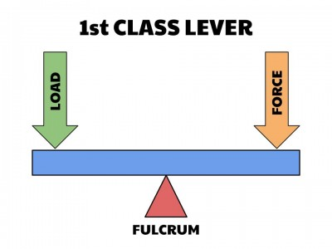
  - resistance (interchangeable with load) in the middle
  - eg. pushup
- 3rd class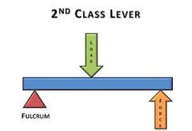
  - force in the middle
  - eg. bicep curl, golf club, baseball bat, tennis racquet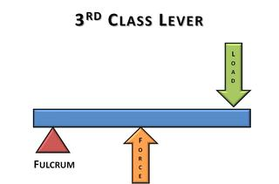
- Force increased by making the force arm longer than resistance arm
- Speed increased by making force arm shorter than resistance arm

Factors affecting Levers
- Length
- Inertia
- Amount of force

Fluid Mechanics
- Fluids of interest
  - Water and Air
- Fluid forces have little effect on some objects (shot put) but major effects on other objects (shuttlecock)
- Major fluid forces of interest
  - Drag
  - Lift
  - Buoyancy

Drag and Lift
- Inverse relationship
- The greater the disturbance to the fluid, the greater the transfer of energy from object to fluid
- 2 factors affecting fluid resistance:
  - Density
    - Eg. humid conditions will increase fluid resistance
  - Viscosity
    - Eg. honey as opposed to water, water as opposed to air

Surface Drag
- Friction produced between fluid and surface of a moving object
- Factors affecting:
  - Relative velocity of moving object
  - Relative roughness of surface object
  - Viscosity of fluid
  - Surface area of the object

Form Drag
- Resistance created by pressure differential between front and back of an object moving through a fluid
- Factors affecting:
  - Cross sectional area of object
  - Velocity of object
  - Surface roughness
  - Shape of object

Wave Drag
- Resistance formed by creation of waves at the point where air and water interact
- Factors affecting:
  - Relative velocity of wave
  - Technique
  - Open water vs closed condition

Boundary Layer
- Thin layer of air surrounding or attached to the ball
  - Laminar – smooth, slow moving ball
    - Early boundary separation
    - Large pressure differential
  - Turbulent – rough, fast moving ball
    - Later boundary separation,
    - Smaller pressure differential
- Separation
  - Where boundary layer breaks from ball
  - Earlier separation occurs, the greater the pressure gradient between the front and back of the ball
- Factors
  - Velocity
  - Surface Roughness

Factors affecting drag
- Drag Coefficient
- Cross Sectional Area
- Speed
- Surface Roughness
- Mass
- Shape

Environmental Factors Affecting Drag
- Air Density
- Atmospheric Pressure
- Humidity
- Temperature

Buoyancy
- Archimedes Principle
  - The buoyant force acting on an object Is equal to the weight of the fluid displaced by the object
- Positive buoyancy
  - Float
- Negative Buoyancy
  - Sink
- Neutral buoyancy
  - Suspends

Bernoulli’s Principle
- Velocity is inversely proportional to pressure
  - High velocity = low pressure
- Lift occurs when there’s higher pressure below the object

Magnus Effect
- Term used to describe the effect of rotation on an object’s path as it moves through a fluid

Top spin
- High pressure on top of the ball causing it to dip faster
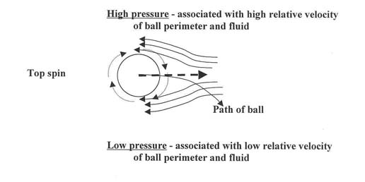
Back Spin
- High pressure of the bottom of the ball causing it to float
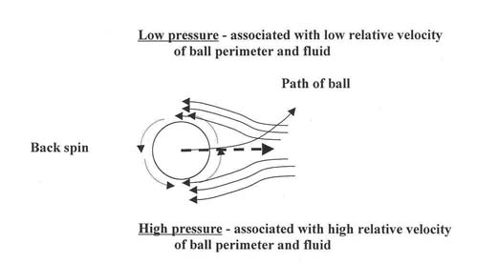
Side Spin
- High pressure on one side of the ball causing it to curve the other way

Formula’s to remember:
Force = mass*acceleration (F=m*a)
Momentum = mass*velocity (P=m*v)
Impulse = force*time (I=f*t)
Torque = force*distance from axis of rotation (t=f*d)
Moment of inertia = mass*radius of rotation

Angular Momentum
- Angular velocity*moment of inertia
- Moment of inertia = mass*radius of rotation

